A

PROJECT REPORT

ON

# “ ELECTROHUB ”

DEVELOPED AT:



**SHREE C. U. SHAH COLLEGE OF MANAGEMENT & COMPUTER EDUCATION, WADHWAN**

**SUBMITTED BY:**

Makwana Harshil M. (003203211016)

Salaiya Satish. (003203211057)

Affiliated to:

Saurashtra University

# “ELECTROHUB”



**SUBMITTED TO:**



**SHREE C. U. SHAH COLLEGE OF**

**MANAGEMENT & COMPUTER EDUCATION, WADHWAN**

Affiliated to:

Saurashtra University

**GUIDED BY: DEVELOPED BY:**

Kirtan Sanghvi Makwana Harshil M. (003203211016)

Salaiya Satish. (003203211057)

**ACADEMIC YEAR: 2024-25**

**BCA SEM – 6**

## CANDIDATE’S DECLARATION

I, **Makwana Harshil M.**  declare that final year report entitled **“Electrohub”** is my own work conducted under the supervision of  **Kirtan Sanghvi** the project guide of “**Electrohub**”.

I further declare that to the best of my knowledge the report for BCA 6th semester does not contain part of the work which has been submitted for the eligible for BCA degree either in this or any other university without proper citation.

Submitted To:

Kirtan Sanghvi

Department of Computer Science, C. U. Shah College. Wadhwan City, State: Gujarat.

Makwana Harshil M

Branch: Computer Application

## CANDIDATE’S DECLARATION

I, **Salaiya Satish H.**  declare that final year report entitled **“Electrohub”** is my own work conducted under the supervision of  **Kirtan Sanghvi** the project guide of “**Electrohub**”.

I further declare that to the best of my knowledge the report for BCA 5th semester does not contain part of the work which has been submitted for the eligible for BCA degree either in this or any other university without proper citation.

Submitted To:

Dr. Viral Dagli

Department of Computer Science, C. U. Shah College. Wadhwan City, State: Gujarat.

Salaiya Satish H.

Branch: Computer Application

## ACKNOWLEDGEMENT

As of now of time when we are composing this documentation, we had an opportunity to look four months back when we were at this point to take up any project close by taking into consideration this cut of time and the status now, we unequivocally feel a feeling of distinction, a feeling of having developed. We consider our self-lucky to be served this excellent piece of information and experience for four valuable months we spent at Shree C. U. Shah College of Management & Computer Education, Wadhwan.

For this, we are very thankful to our college that provided their resources in making us competent and deserving of taking up such a difficult undertaking. For this undertaking project that needs an additional knowledge and guidance for the successful development, we say thanks to Kirtan Sanghvi , Department of B.C.A division.

## ABSTRACT

“ Welcome to“Electrohub.com”.

* You can order electronics accessories anytime.
* You have to register and login in this website.
* We are your one-stop destination for your all electronics accessories .
* We provide latest Bluetooth speakers, wireless headphones , and much more .
* In our website we provide all top brands of electronic accessories .
* we also give facility of easy way of search and also give option of review and ratings.
* We also give different offers on products so visitors can get more benefits.
* Explore products review to make in decision and stay ahead in the ever evolving world of

electronic accessories .

* If you are not logged in, you will need to enter your email id or password.
* Only then you can order electronic items.

## INDEX

**Cover Page I**

**First Page Ii**

**Candidate’s Declaration Iii**

**College Certificate V**

**Acknowledgement Vii**

**Abstract Ix**

**1.0 Introduction 1**

1.1 Project Details 1

1.2 Purpose 1

1.3 Scope 2

1.4 Objectives 2

**2.0 Project Management 3**

2.1 Feasibility Study 3

2.1.1 Technical Feasibility 3

2.1.2 Operational Feasibility 3

2.1.3 Economical Feasibility 3

2.2 Project Planning 4

2.2.1 Project Development Approach & Justification 4

2.3 Project Scheduling 5

**3.0** **System Requirements Study** **7**

3.1 Study of current system7

3.2 Problems and weakness of current system 7

3.3 Hardware and software Requirement 8

**4.0** **Requirement of Proposed System** **9**

4.1 Main Modules of the System9

4.2 Module Description 9

4.3 Features of New System 10

**5.0** **System Design** **11**

5.1 System architecture Design11

5.1.1 E-R diagram 11

5.1.2 Use Case diagram 12

5.1.3 Data Flow diagram 15

5.1.4 Activity diagram 19

5.2 Data Dictionary 20

5.3 Sample code 27

5.4 Screenshot 35

**6.0** **Testing** **66**

6.1 Test Cases66

**7.0** **Limitations and Future Extensions** **69**

7.1 Limitations 69

7.2 Future Extensions 69

**8.0** **Conclusion and References** **70**

8.1 Conclusion **70**

8.2 References 70

1: Introduction Project ID: 43

# INTRODUCTION

**1.1 PROJECT DETAILS**

Welcome to “Electro Hub.com” your one stop destination for electronic accessories. Electro Hub is a dynamic online platform that provides a collection of state-of-the-art electronic accessories. We provide latest Bluetooth speakers, wireless headphones, and much more. Our website serves as a one-stop destination for users seeking high-quality and innovative products electronic devices and daily tech experiences. Electro Hub brings together a diverse array of accessories that seamlessly integrate with the latest technological trends. Our website provides detailed product descriptions, customer reviews, and expert recommendations. We aim to offer a seamless and user-friendly experience with detailed product information customer reviews, and secure online transaction.

Join us in exploring the endless electronics accessories making you more enjoyable efficient & stylish.

**1.2 PURPOSE**

The purpose of our website is to provide the facility of dynamic search. And we are trying to provide a secure environment so that user can easily use the site. It is a web-based application for ordering electronic accessories.

Our goal is to be trusted source for all electronic accessories, providing information reviews & recommendation to help users to make informed decision.

1: Introduction Project ID: 43

**1.3 SCOPE**

* The project consists the list of electronic accessories like, Headphones,

Bluetooth speaker, Smart Watches and much more. If the user is interested in any product then can order online from this site.

* Once user wishes to order he must register on the site first. He can get login id further surfing.

**1.4 OBJECTIVES**

* The main objective of our site is to allow user for purchase and giving all information about our electronic accessories like price of accessories and gallery and other facilities.
* Providing customer satisfaction is the main objective of our site.
* Less time consuming and making the system totally online.

# PROJECT MANAGEMENT

**2.1 FEASIBILITY STUDY:**

**2.1.1 Technical Feasibility:**

In technical feasibility the main aim is that the system can work with the current man and equipment. Our project can work with current operating system and current configuration so our project is feasible at the view of technical feasibility.

**2.1.2 Operational Feasibility:**

Our project is satisfied the requirement of operational feasibility. In operational feasibility here are few question for checking the satisfaction of the operational feasibility. In operational feasibility main aim is that the current member can operate the system. Our project can be operatable by any person. So, our project feasible at the point of operational feasibility.

**2.1.3 Economical Feasibility:**

Economical feasibility benefits the project that it must exceed or at least be equal to the cost of development. It analysis is the most commonly used method for determining the efficiency of a new project. It helps in identifying profit against investment expected from a project. Cost and time are the most essential factors involved in this field of study.

**2.2 PROJECT PLANNING:**

**2.2.1 Project Development Approach & Justification:**

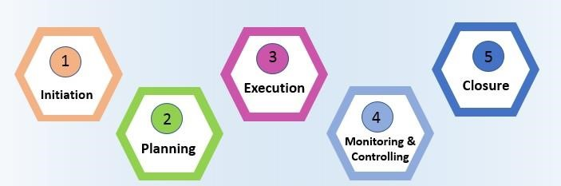

**How use this model for developing this project**

* In the initiation phase, you will define the project. You will sort out the project goals, scope, and resources of the project and what roles are needed on the team. Clarifying what stakeholders expect out of the project, and what exactly the project is aiming to achieve (and why) will give the project and team clear direction.
* In the planning phase, you will determine the steps to actually achieve the project goals— the “how” of completing a project. You will establish budgets, timelines, milestones, source materials, and necessary documents. This step also involves calculating and predicting risk, establishing change processes in place, and outlining communication protocols. If the initiation phase is assembling your troops, the planning phase is deciding what to do with them.
* Executing a project means putting your plan into action and keeping the team on track. Generally, this means tracking and measuring progress, managing quality, mitigating risk, managing the budget, and using data to inform your decisions. Specific steps might include:
  + - Using tools like DFD and E-R or burndown charts to track progress on tasks o Responding to risks when they manifest
    - Recording costs o Keeping team members motivated and on task o Keeping stakeholders informed of progress o Incorporating changes via change requests
* In the closing phase of the project management lifecycle, you will conclude project activities, turn the finished product or service over to its new owners and assess the things that went well and did not go so well. It will also be a time to celebrate your hard work. Steps in the closing phase can include:
  + - Conducting retrospectives and take notes of changes you can implement in the future.
    - Communicating to stakeholders at the end of the project and providing an impact report o Communicating with the new owners of a project. o Creating a project closeout report o Celebrating the end of the project and your successes

**2.2 PROJECT SCHEDULING:**

Scheduling in project management is the listing of activities, deliverables, and milestones within a project. A schedule usually includes a planned start and finish date, duration, and resources assigned to each activity. Effective project scheduling is a critical component of successful time management, especially for professional service businesses.

In this guide, we will explore the concept of scheduling in project management, its importance, and how it is done. We will also look into the different scheduling techniques, tools, and best practices that project managers can leverage to keep their projects on track and deliver successful outcomes.

If you are looking for a tool that will allow you to have full control over the scheduling processes for your projects, Wrike has the right solution for you. You can start today and unlock the full power of project management.

Resources required for Development of Project:

* Human effort
* Sufficient disk space on server
* Specialized hardware
* Software technology
* Travel allowance required by project staff, etc.

**Advantages of Project Scheduling:**

* It simply ensures that everyone remains on same page as far as tasks get completed, dependencies, and deadlines.
* It helps in identifying issues early and concerns such as lack or unavailability of resources.
* It also helps to identify relationships and to monitor process.
* It provides effective budget management and risk mitigation.

3 System Requirement Study Project

# SYSTEM REQUIREMENT STUDY

**3.1 STUDY OF CURRENT SYSTEM**

This system provides a common platform through which user can order the electronics accessories. Here user can register and then order any electronics accessories. Each time changes in database should be updated. So there would be very low performance.

Online ordering sites offers description, picture of accessories, product colour, and much more. For example of these are “www.banggood.in”,” www.monoprice.com” etc …

**3.2 PROBLEMS AND WEAKNESS OF CURRENT SYSTEM**

* System are difficult to user further for searching.
* It’s provide to long produce to be completed quick produce.
* It’s provide less functionality and less accuracy.
* Security of user data is a serious issue and you have to make sure it is properly deal by login Id and password.

3 System Requirement Study Project

**3.3 HARDWARE AND SOFTWARE REQUIREMENTS:**

**Hardware Requirements (Minimum):**

|  |  |
| --- | --- |
| **Component** | **Specification** |
| Processor | Intel Core 5 |
| RAM | 8 GB RAM |
| Hard Disk | 500 GB |

**Software Requirements**

**Operating System:** Windows 11

**Front End Tools**: asp.net

**Back End Tools:** MySQLserver

**Office Automation Tools:**

* Microsoft Office Word
* Microsoft Visio

4 Requirement of Proposed System Project

# REQUIREMENT OF PROPOSED SYSTEM

**4.1 MAIN MODULES OF THE SYSTEM:**

There are basically three main modules in the systems.

* Admin User
* Registered User
* Visitor User

**4.2 MODULE DESCRIPTION:**

There are three modules in this system.

**1) Admin User:**

* The admin user can manage electronic accessories website by adding, editing or removing products & categories.
* They can also manage view orders, users account & update the website content.

**2) Registered User:**

* Reg user can access features like saved order history, shipping address & payment methods.
* Register user can do various function like search, view etc.
* Reg user can get features like OTP services while login with phone. And

OTP will get through SMS or Email

**3) Visitor:**

* Visitor user can search, view all the details of products, related to their needs.
* Visitor user can do free registration.
* Visitor user can give feedback for the site.
* Visitor see all the review of electronic accessories.

1. Requirement of Proposed System Project

**4.3 FEATURES OF NEW SYSTEM:**

* There are some features that can be having new proposed system.
* This proposed system will be more secure and aciculate.
* It will be maintained & updated time to time.
* Proposed system must be work efficiently and speedly.
* As well as like new era must be more secure and fast.
* This proposed new system is very user friendly.

# SYSTEM DESIGN

**5.1 SYSTEM ARCHITECTURE DESIGN:**

**5.1.1 ER Diagram :**

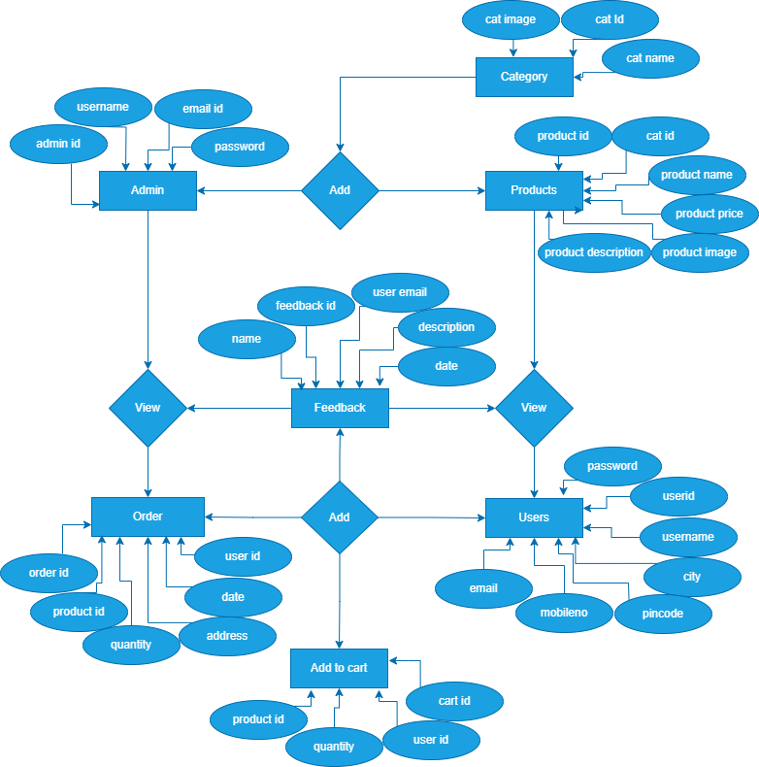

## Figure 5.1: E – R Diagram

**5.1.2 Use case Diagram:**

**a) Admin :**

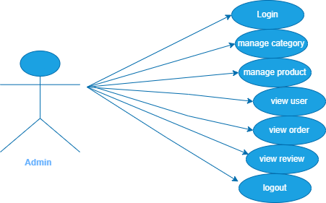

## Figure 5.2: Use case Diagram for Admin

**b) Register User:**

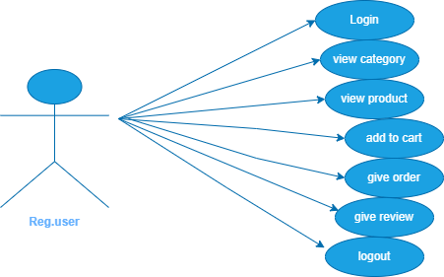

## Figure 5.3: Use case Diagram for Register

**c) Visitor :**

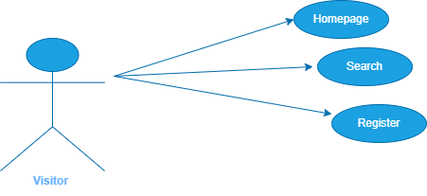

## Figure 5.4: Use case Diagram for Visitor

**5.1.3 Data Flow Diagram:**

**a) Context Diagram :**

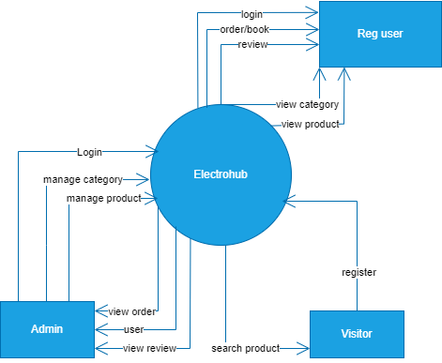

## Figure 5.5: Context Diagram

**Level 1 Data Flow Diagram :**

**a)**  **Admin :**

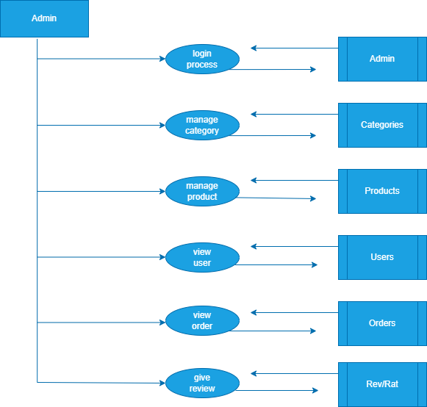

## Figure 5.6: 1 - Level Data Flow Diagram

**b) Register User :**

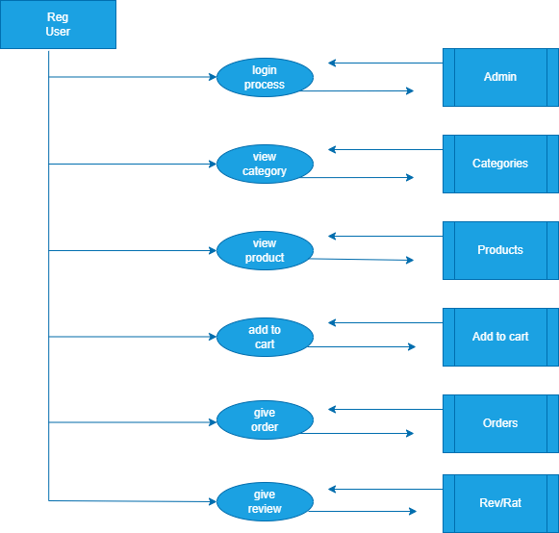

## Figure 5.7: 1 - Level Data Flow Diagram

**c) Visitor :**

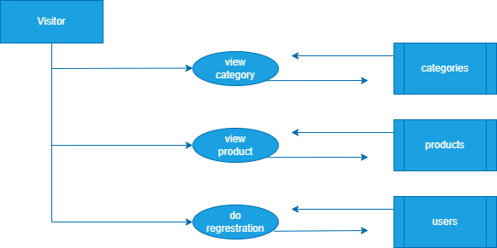

## Figure 5.8: 1 - Level Data Flow Diagram

**5.1.4 Activity Diagram :**

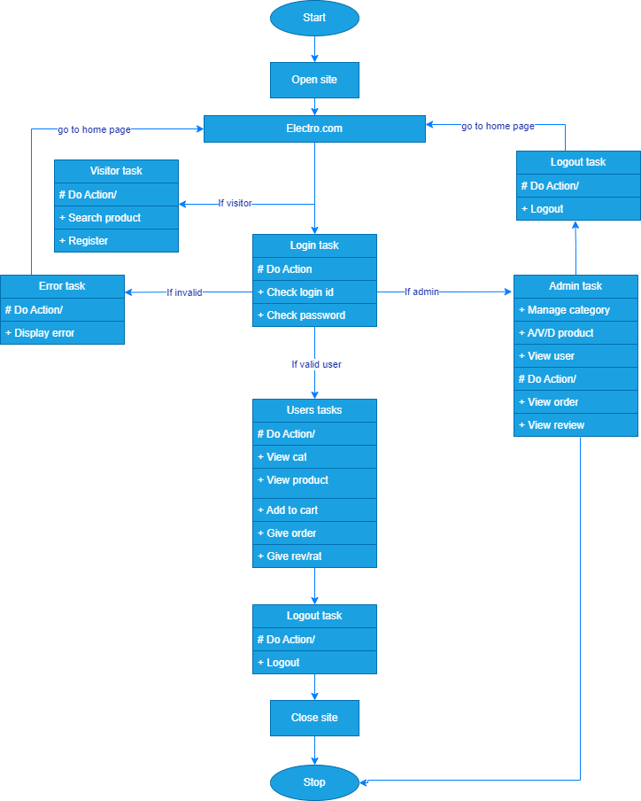

## Figure 5.9: Activity Diagram

**5.2 DATA DICTIONARY**

**Table Name:** admins

**Description:** Store admin details

|  |  |  |  |  |  |
| --- | --- | --- | --- | --- | --- |
| **SR. No** | **FIELD NAME** | **DATA TYPE** | **SIZE** | **CONSTRAINT** | **DESCRIPTION** |
| 1 | Admin Id | Int | 5 | Primary key | Id of admin |
| 2 | Admin Name | Text | 50 | Not null | Name of admin |
| 3 | Password | Text | 50 | Not null | Password of admin |
| 4 | Admin Email | Text | 50 | Unique key | Email of admin |

**Table Name:** users

**Description:** Store user details

|  |  |  |  |  |  |
| --- | --- | --- | --- | --- | --- |
| **SR. No** | **FIELD NAME** | **DATA TYPE** | **SIZE** | **CONSTRAINT** | **DESCRIPTION** |
| 1 | User Id | Int | 5 | Primary key | Id of user |
| 2 | User name | Text | 50 | Not null | Name of user |
| 3 | User email | Text | 50 | Unique key | Email of user |
| 4 | City | Text | 50 | Not null | City of user |
| 5 | Password | Text | 50 | Not null | Password of user |
| 6 | Mobile no | Text | 50 | Not null | Mobile no of user |
| 7 | Pincode | Int | 6 | Not null | Pincode of user |

**Table Name:** products

**Description:** Store product details

|  |  |  |  |  |  |
| --- | --- | --- | --- | --- | --- |
| **SR. No** | **FIELD NAME** | **DATA TYPE** | **SIZE** | **CONSTRAINT** | **DESCRIPTION** |
| 1 | P Id | Int | 5 | Primary key | Id of product |
| 2 | P Name | Text | 50 | Not null | Name of product |
| 3 | P Image | Text | 50 | Not null | Image of product |
| 4 | P Price | Int | 5 | Not null | Price of product |
| 5 | Cat Id | Int | 5 | Reference key | Id of categories |
| 6 | P Description | Text | 50 | Not null | Detail of product |

**Table Name:** orders

**Description:** Store order details

|  |  |  |  |  |  |
| --- | --- | --- | --- | --- | --- |
| **SR. No** | **FIELD NAME** | **DATA TYPE** | **SIZE** | **CONSTRAINT** | **DESCRIPTION** |
| 1 | Order Id | Int | 5 | Primary key | Id of order |
| 2 | User Id | Int | 5 | Reference key | Id of user |
| 3 | Date | date | _ | Not null | Date of order |
| 4 | Address | Text | 50 | Not null | Address of order |
| 5 | Quantity | Text | 50 | Not null | Quantity of order |
| 6 | P id | Int | 5 | Reference key | Id of product |

**Table Name:** categories

**Description:** Store categories details

|  |  |  |  |  |  |
| --- | --- | --- | --- | --- | --- |
| **SR. No** | **FIELD NAME** | **DATA TYPE** | **SIZE** | **CONSTRAINT** | **DESCRIPTION** |
| 1 | Cat Id | Int | 5 | Primary key | Id of categories |
| 2 | Cat Name | Text | 50 | Not null | Name of categories |
| 3 | Cat image | Text | 50 | Not null | Image of categories |

**Table Name:** feedbacks

**Description:** Store feedbacks details

|  |  |  |  |  |  |
| --- | --- | --- | --- | --- | --- |
| **SR. No** | **FIELD NAME** | **DATA TYPE** | **SIZE** | **CONSTRAINT** | **DESCRIPTION** |
| 1 | Feedback Id | Int | 5 | Primary key | Id of feedback |
| 2 | Date | Date | _ | Not null | Date of user |
| 3 | User Email | Text | 50 | Unique | Email of user |
| 4 | Name | Text | 50 | Not null | Name of user |
| 5 | Description | Text | 50 | Not null | Message of feedback |

**Table Name:** add to carts

**Description:** Store add to cart details

|  |  |  |  |  |  |
| --- | --- | --- | --- | --- | --- |
| **SR. No** | **FIELD NAME** | **DATA TYPE** | **SIZE** | **CONSTRAINT** | **DESCRIPTION** |
| 1 | Cart Id | Int | 5 | Primary key | Id of add to cart |
| 2 | P Id | Int | 5 | Reference key | Id of product |
| 3 | User Id | Int | 5 | Reference key | Id of user |
| 4 | Quantity | Varchar | 5 | Not null | Quantity of product |

**5.3 Sample code:**

**Login Design:**

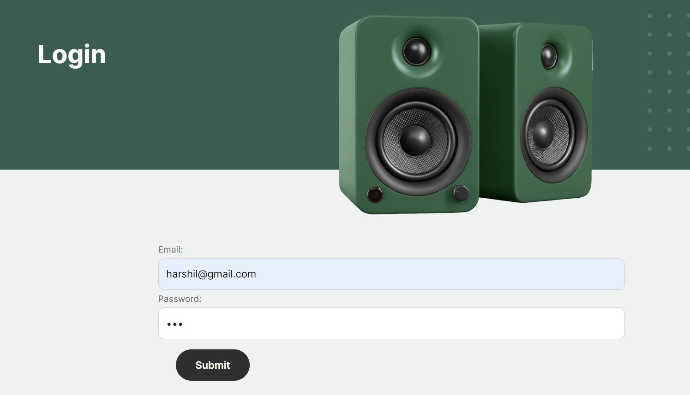

## Login.aspx

<asp:Content ID="Content1" ContentPlaceHolderID="cplace" Runat="Server">

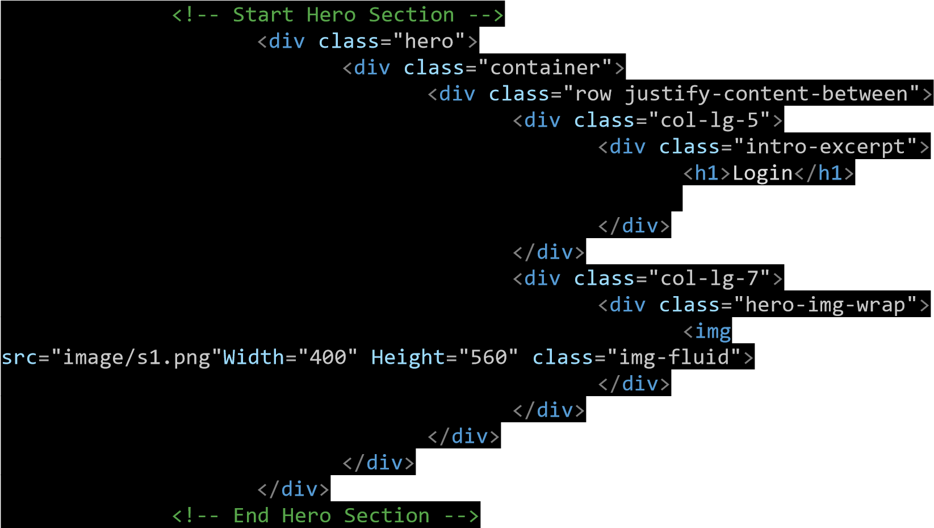

<!-- Start Contact Form -->

<div class="untree_co-section">

<div class="container">

|  |  |
| --- | --- |
| <div class="block"> |  |
| <div class="row justify-content-center"> | |

<div class="col-md-8 col-lg-8 pb-4">

<form runat="server">

<div class="row">

<div class="col-12">

<div class="form-group">

Email:

|  |  |  |
| --- | --- | --- |
| <asp:TextBox ID="txtemail" class="form-control" runat="server" /> | | |
| </div> | |  |
| </div> |  |

<div class="col-12">

<div class="form-group">

Password:

|  |  |  |  |
| --- | --- | --- | --- |
| <asp:TextBox ID="txtPwd" TextMode="Password" class="form-control" | | | |
| runat="server" /> |  | | |
| </div> | | |  |
| </div> | |  |

</div>

<div class="row m-3">

<div class="col-12">

<div class="form-group">

<asp:Button ID="btnSubmit" runat="server" CssClass="btn btndanger" OnClick="btnSubmit_Click" Text="Submit" />

</div>

</div>

</div>

<div class="row m-3">

<div class="col-12">

<div class="form-group">

<asp:Label ID="lblMsg" runat="server" />

</div>

</div>

</div>

</form>

</div>

</div>

</div>

</div>

|  |  |
| --- | --- |
| </div> | |
| </div> |  |

<!-- End Contact Form -->

</asp:Content>

## Login.aspx.cs

using System;

using System.Collections.Generic; using System.Linq; using System.Web; using System.Web.UI;

using System.Web.UI.WebControls;

using System.Data;

public partial class contact : System.Web.UI.Page

{

ConnectionClass con;

protected void Page_Load(object sender, EventArgs e)

{

con = new ConnectionClass();

}

protected void btnSubmit_Click(object sender, EventArgs e)

{

string email= txtemail.Text; string pwd = txtPwd.Text;

string qAdmin = "select * from admin_login where email_id='"+ email + "' and password='" + pwd + "'" ;

string qUser = "select * from user_registration where email='" + email + "' and password='" + pwd + "'";

|  |  |
| --- | --- |
| DataTable dtAdmin = con.allRecord(qAdmin); | |
| DataTable dtUser = con.allRecord(qUser); |  |

if (dtAdmin.Rows.Count > 0)

{

Session["admin_id"] = dtAdmin.Rows[0][0].ToString();

Response.Redirect("admin-home.aspx");

}

e

lse

if

dtUser

(

.

Rows

.

Count

>

0

)

{

Session[

"user_id"

]

=

dtUser

.

Rows[

0

][

0

]

.

ToString();

Response

.

Redirect(

"index.aspx"

)

;

}

e

lse

{

lblMsg

.

Text

=

"Invalid Username and password"

;

}

}

}

**5.4** **Screenshot**:

1. **ADMIN SIDE:** 
   1. **Admin Login Page**

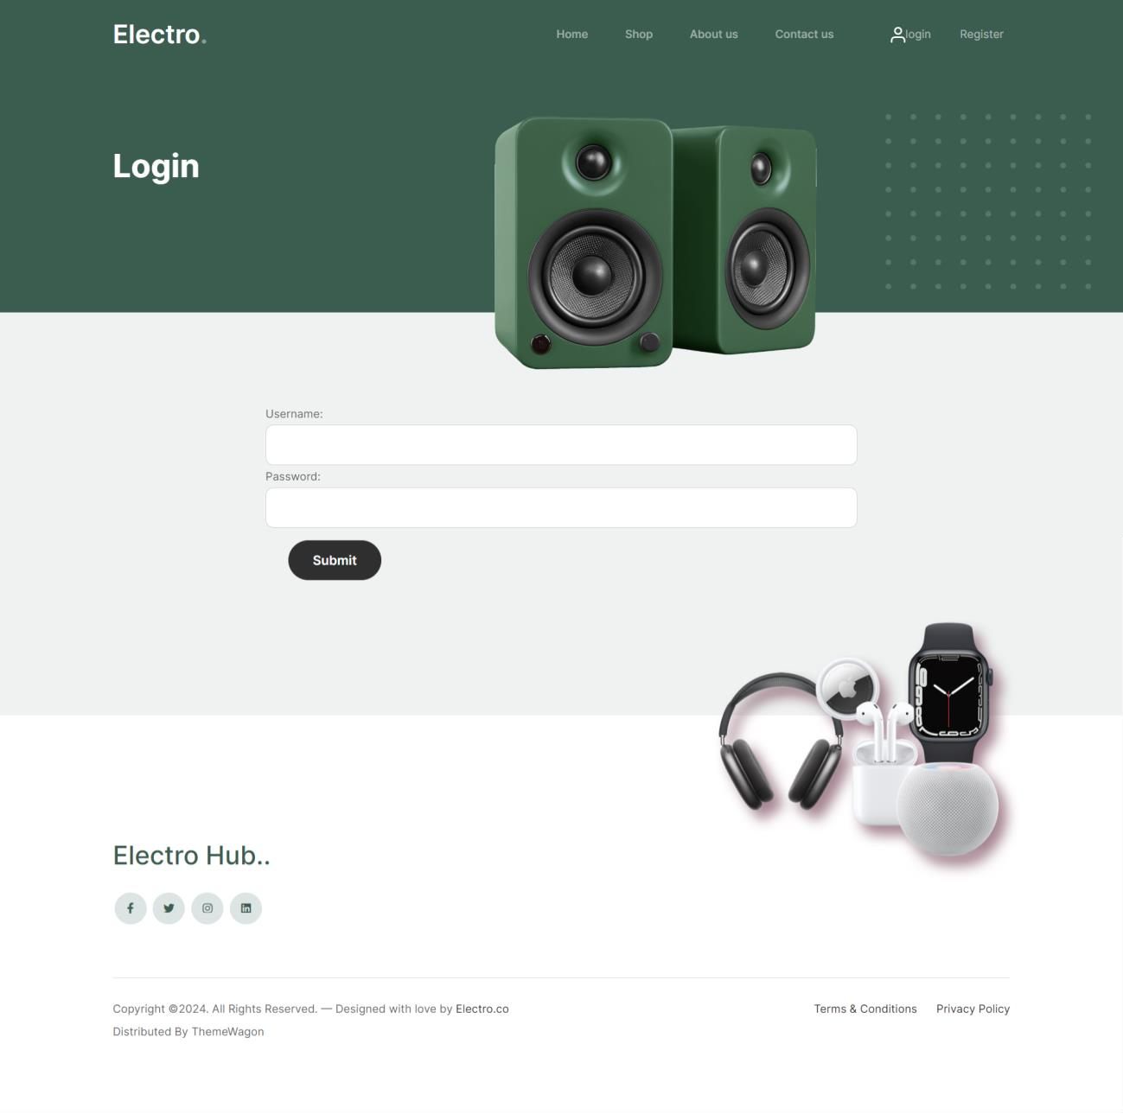

This is the login page of admin.

* 1. **Dashboard**

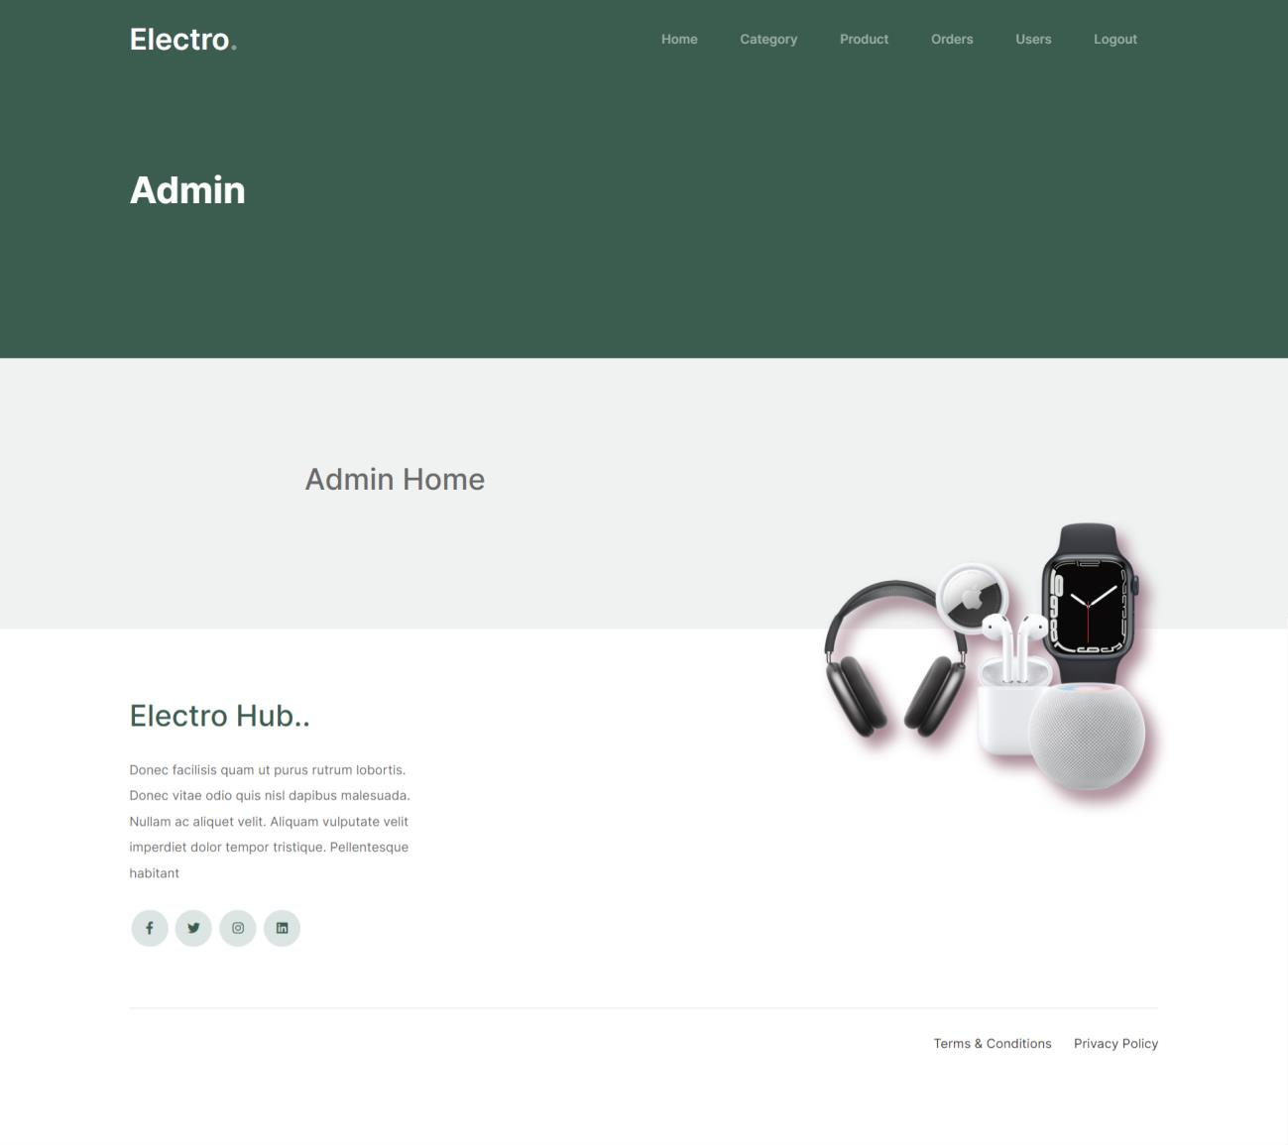

This is a dashboard of admin.

* 1. **Category Add**

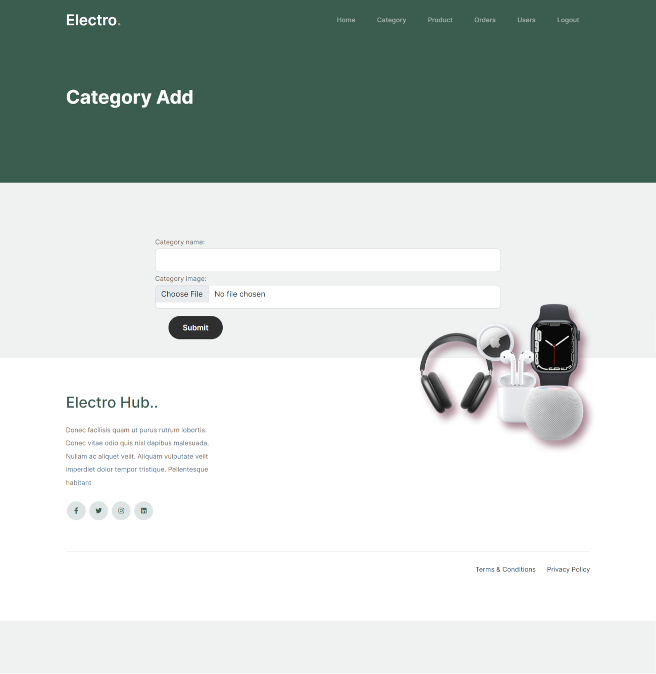

This page for add category.

* 1. **Category View**

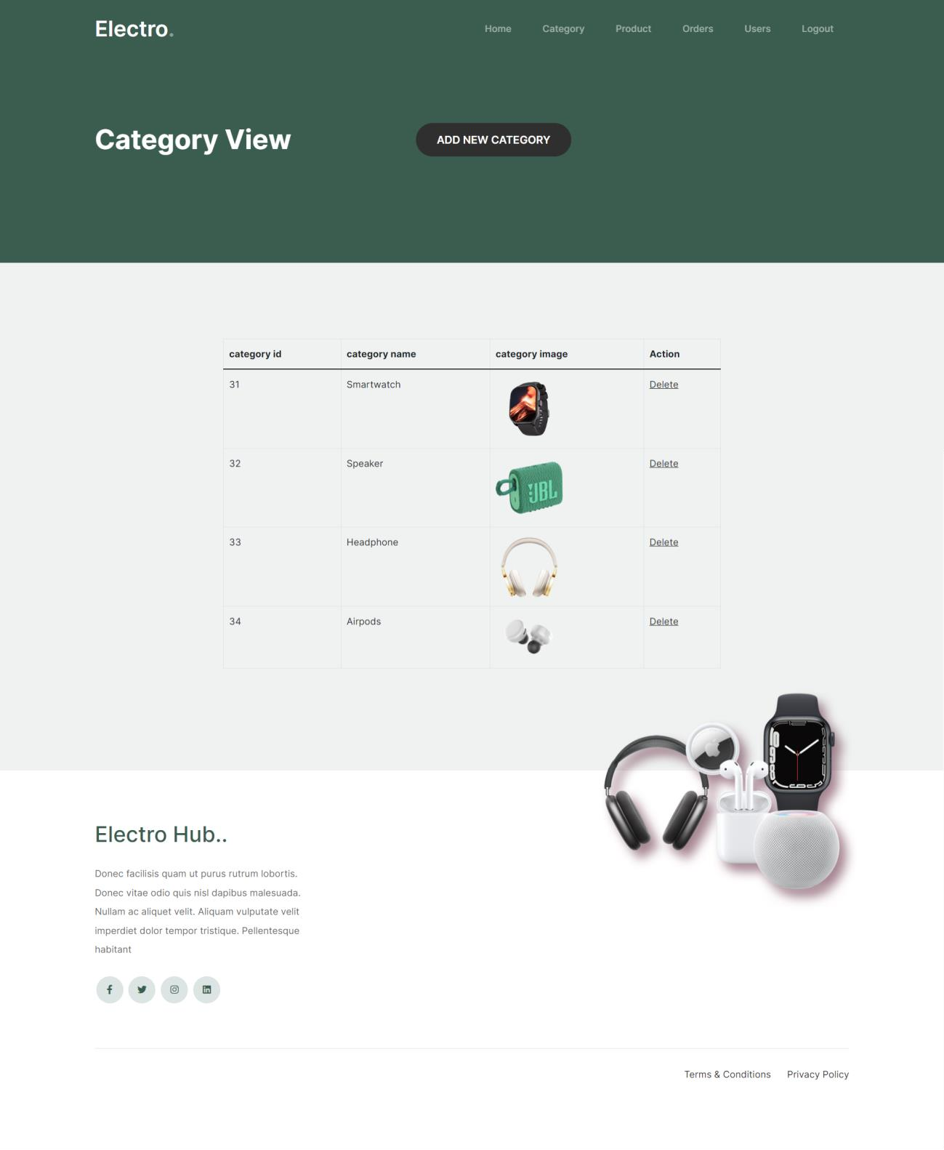

This page for view category.

* 1. **Product Add**

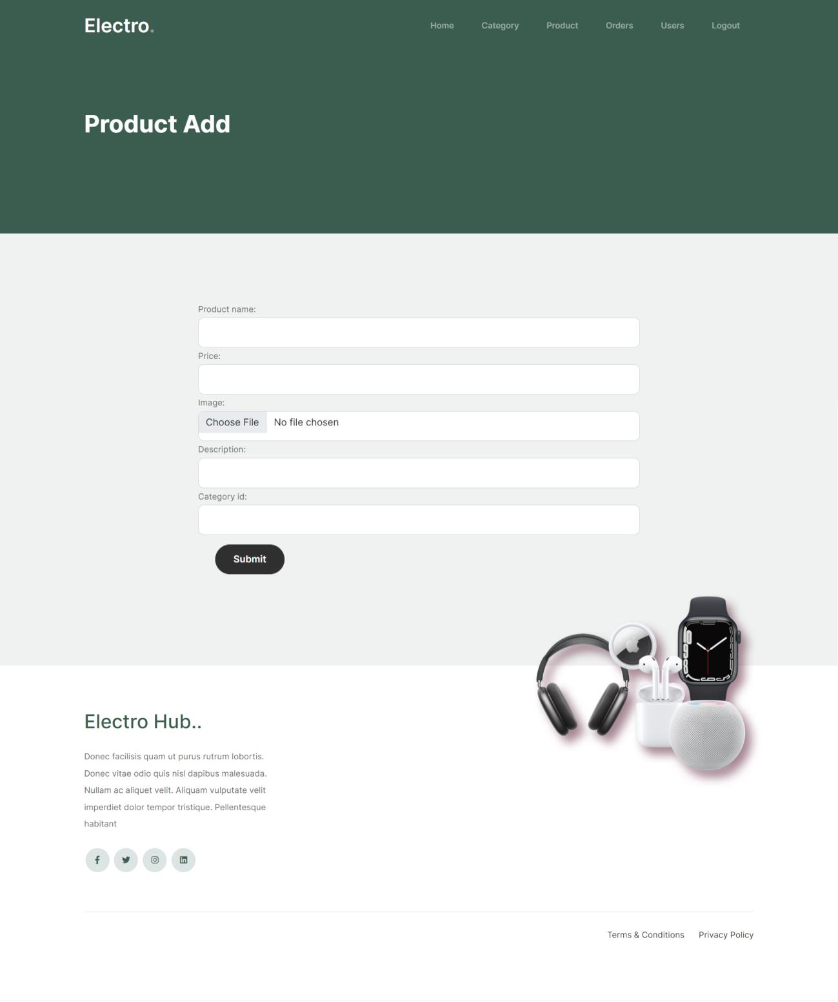

This page for add product.

* 1. **Product View**

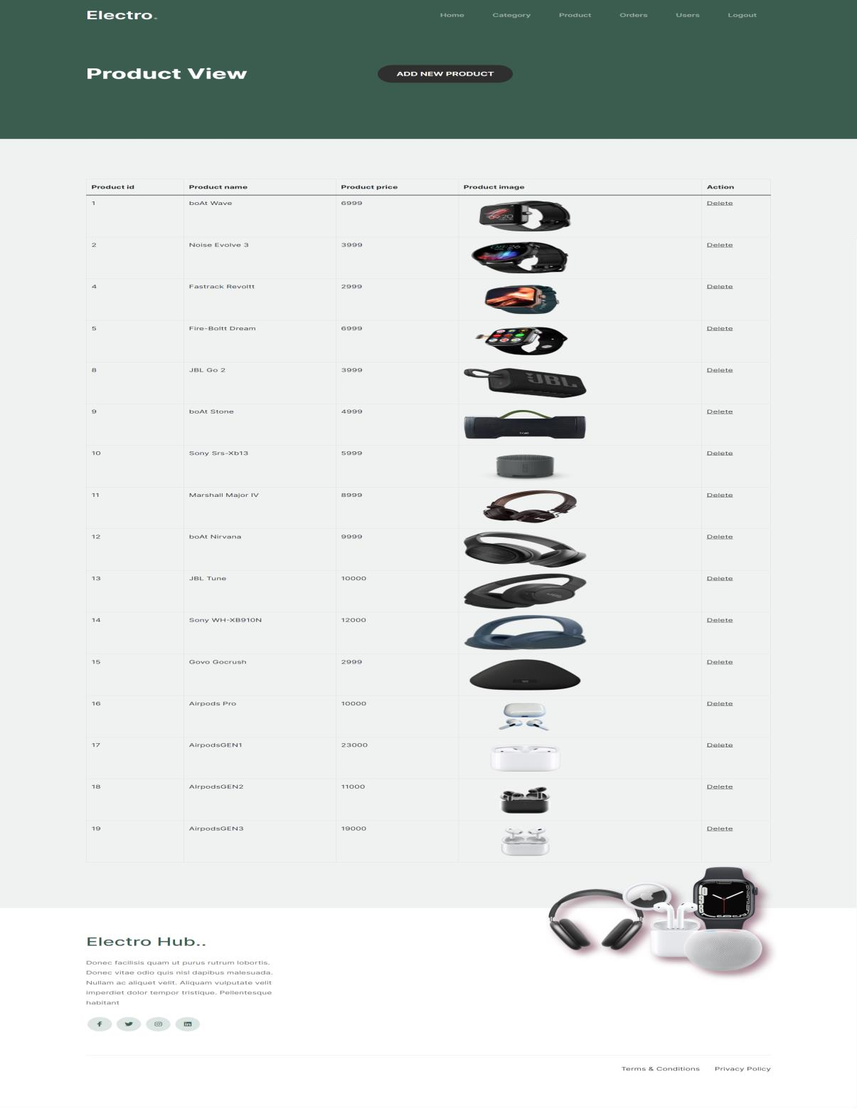

This page for view product.

* 1. **Order View**

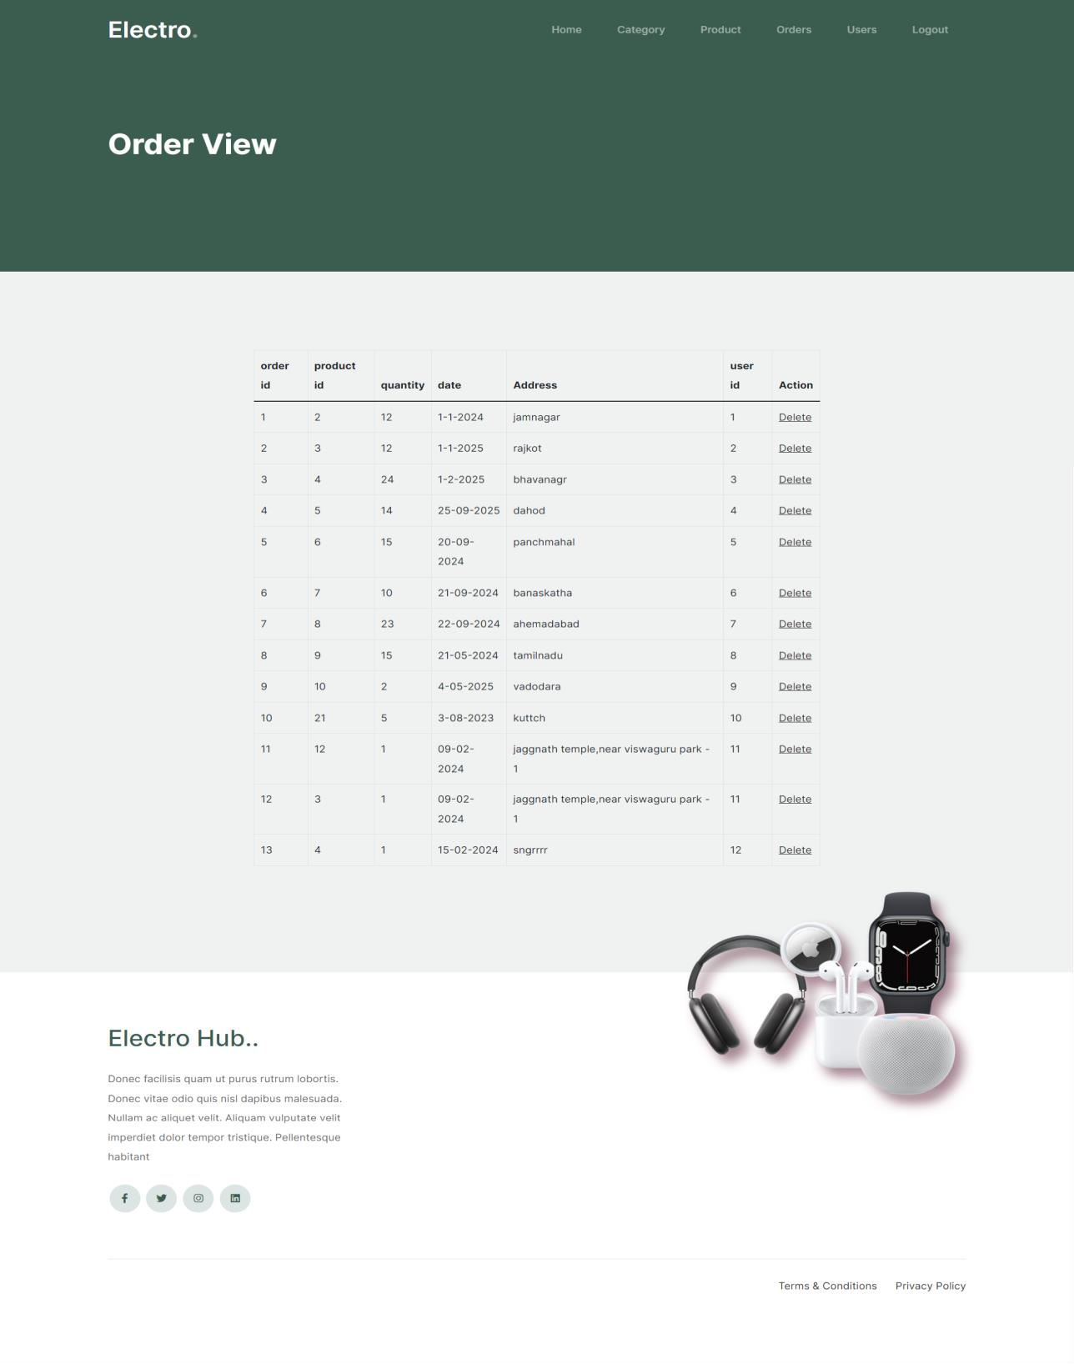

This page for view order.

* 1. **Order Detail**

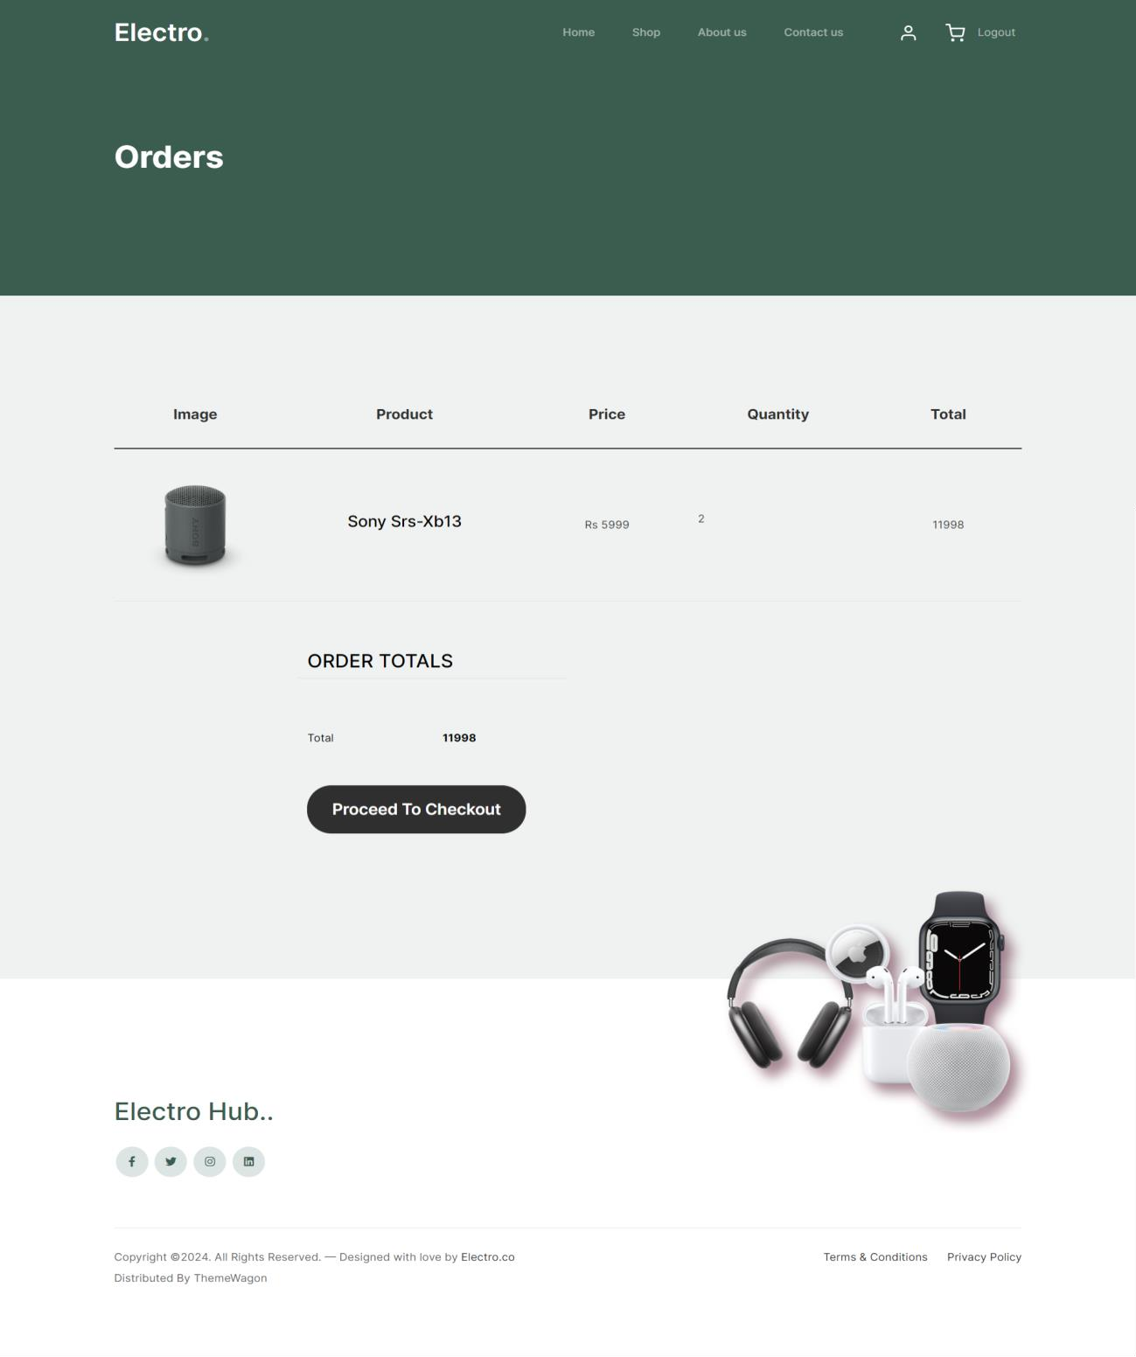

This page for view detail of order.

* 1. **User View**

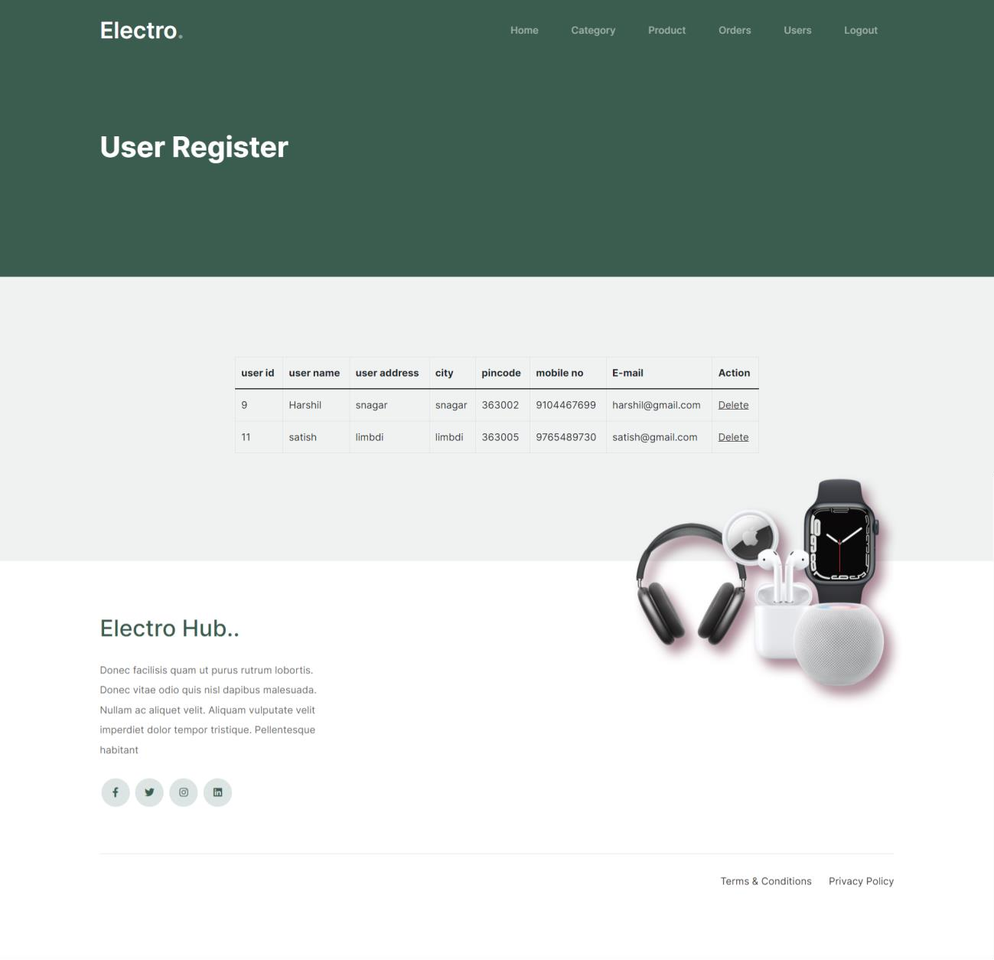

This page for view user.

* 1. **Admin Feedback View**

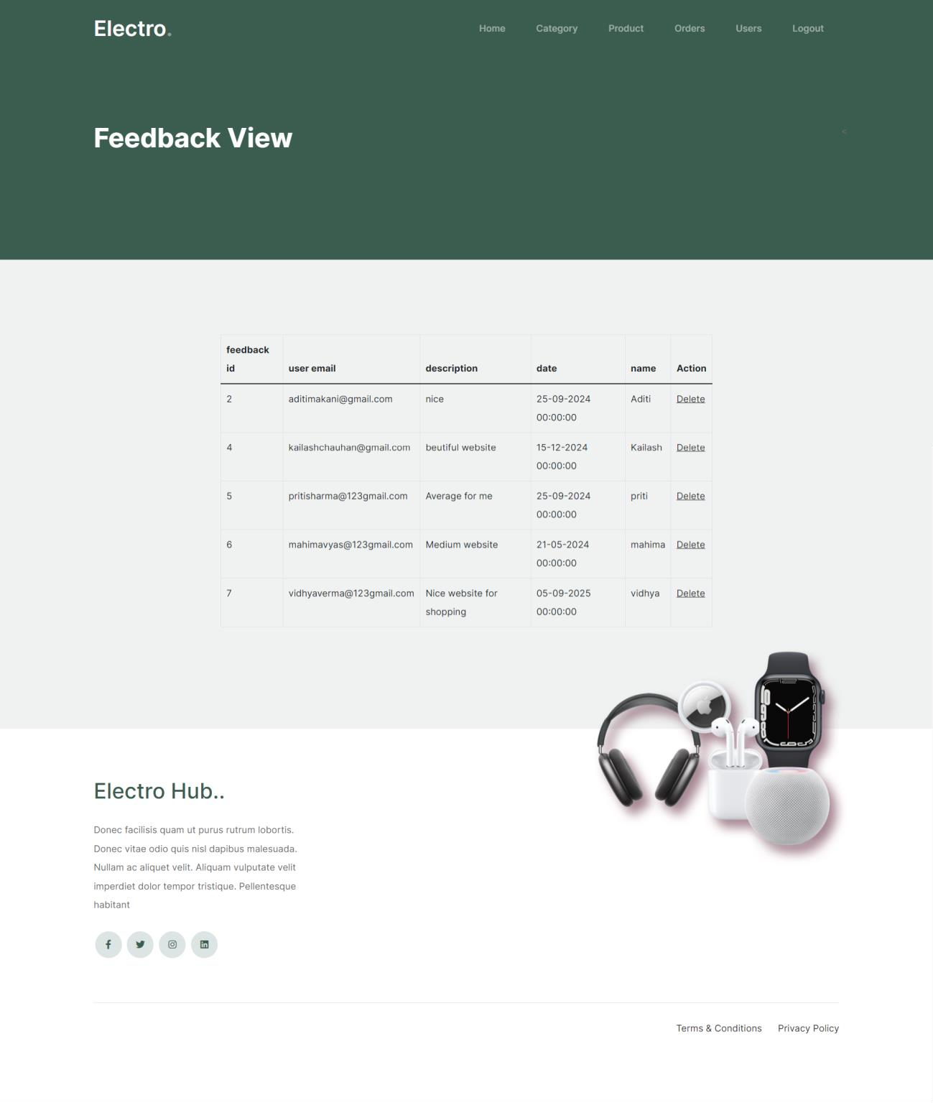

This page for view feedback.

1. **USER SIDE:** 
   1. **User Login Page**



This is the login page.

* 1. **Home Page**

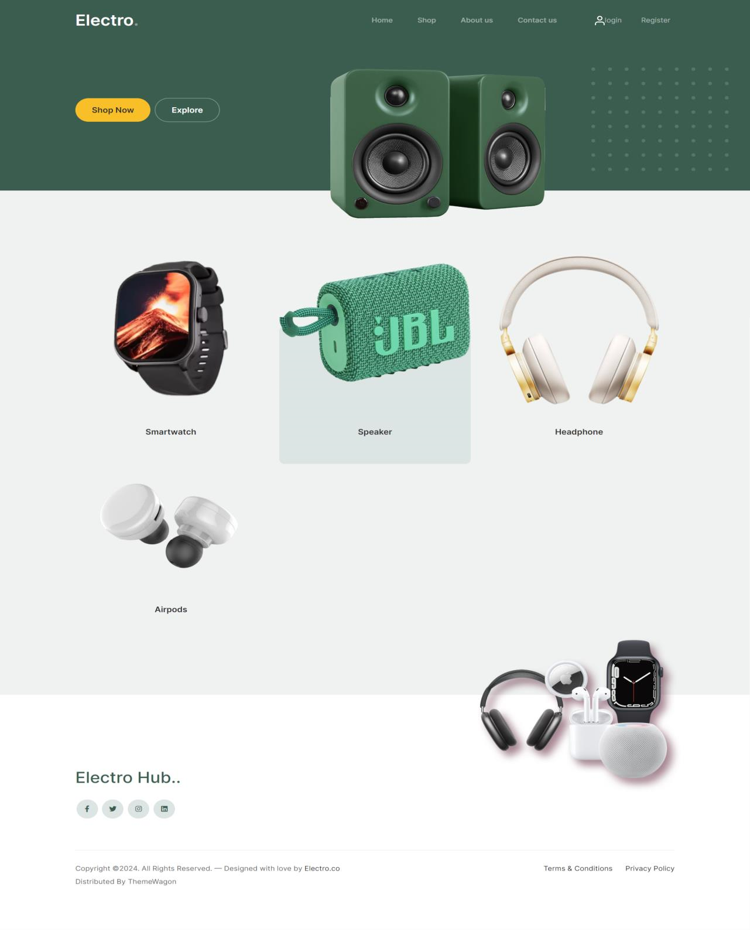

This is home page.

* 1. **About Us**

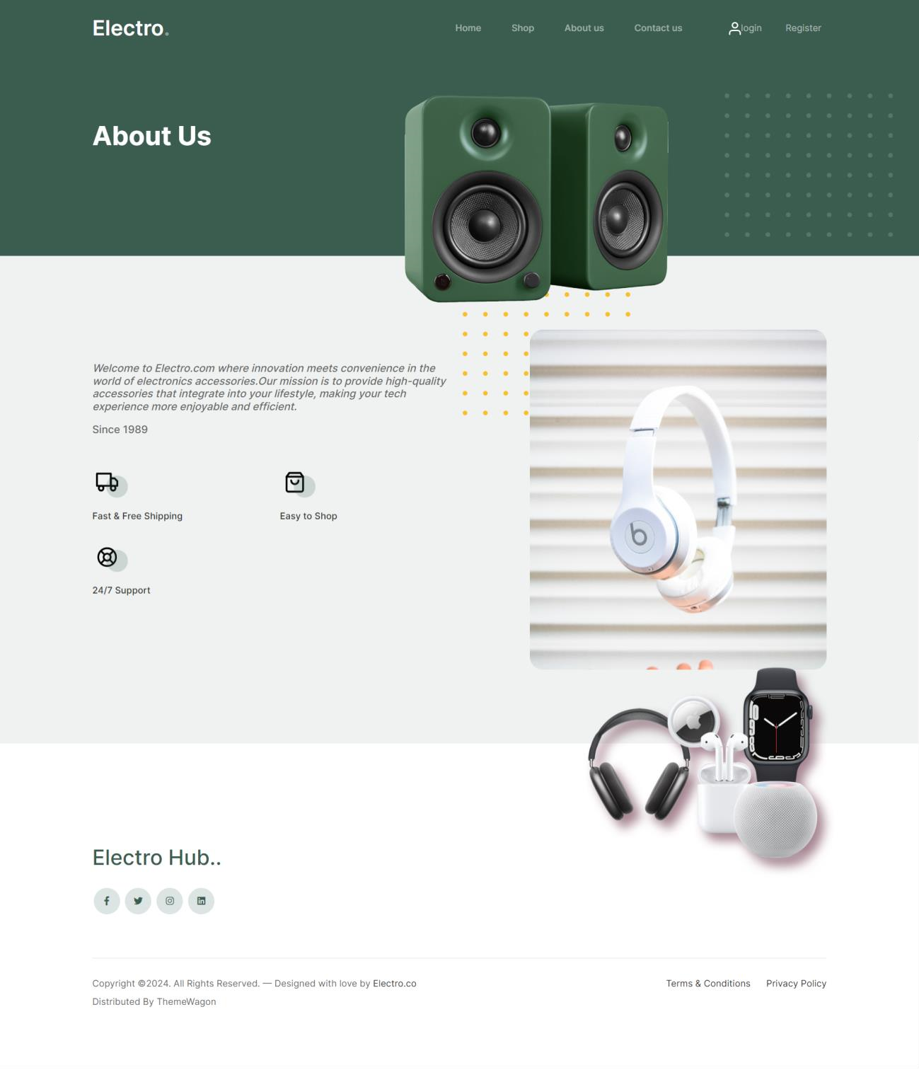

This is about us page.

* 1. **Contact Us**

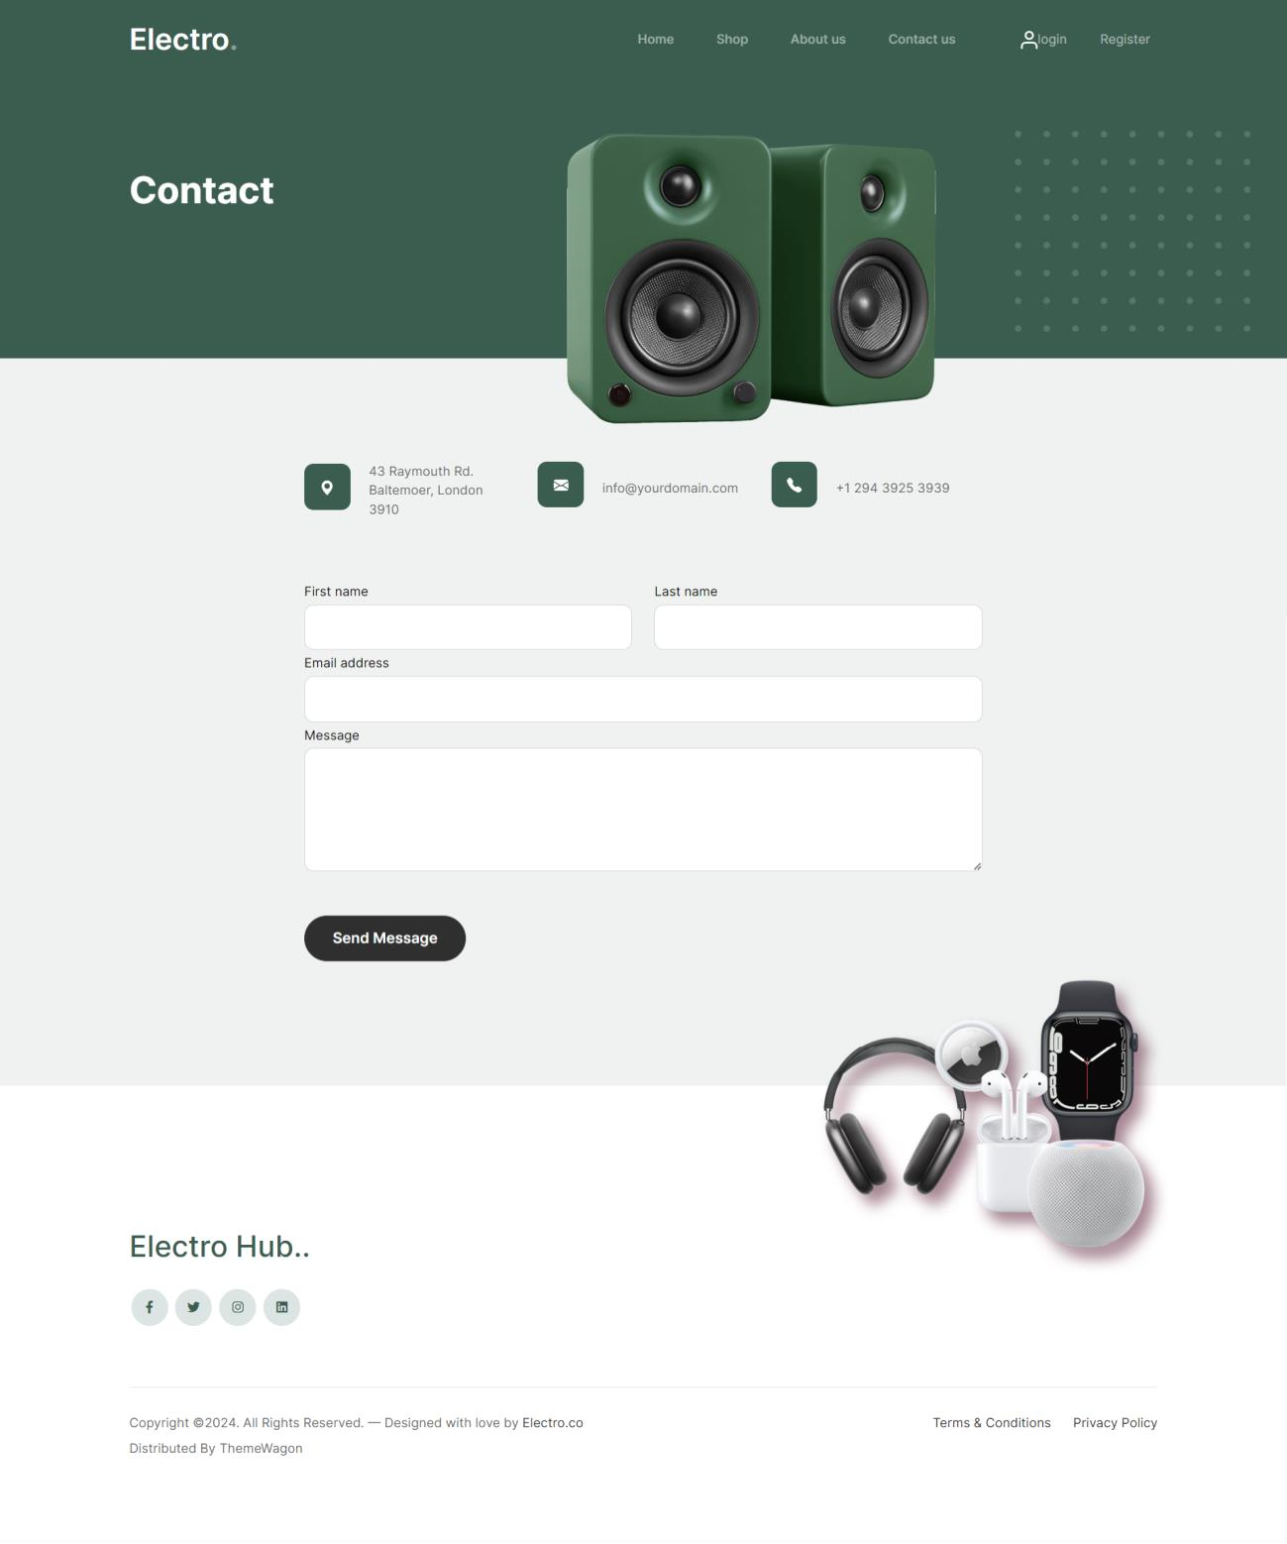

This is Contact us page.

* 1. **Shop**

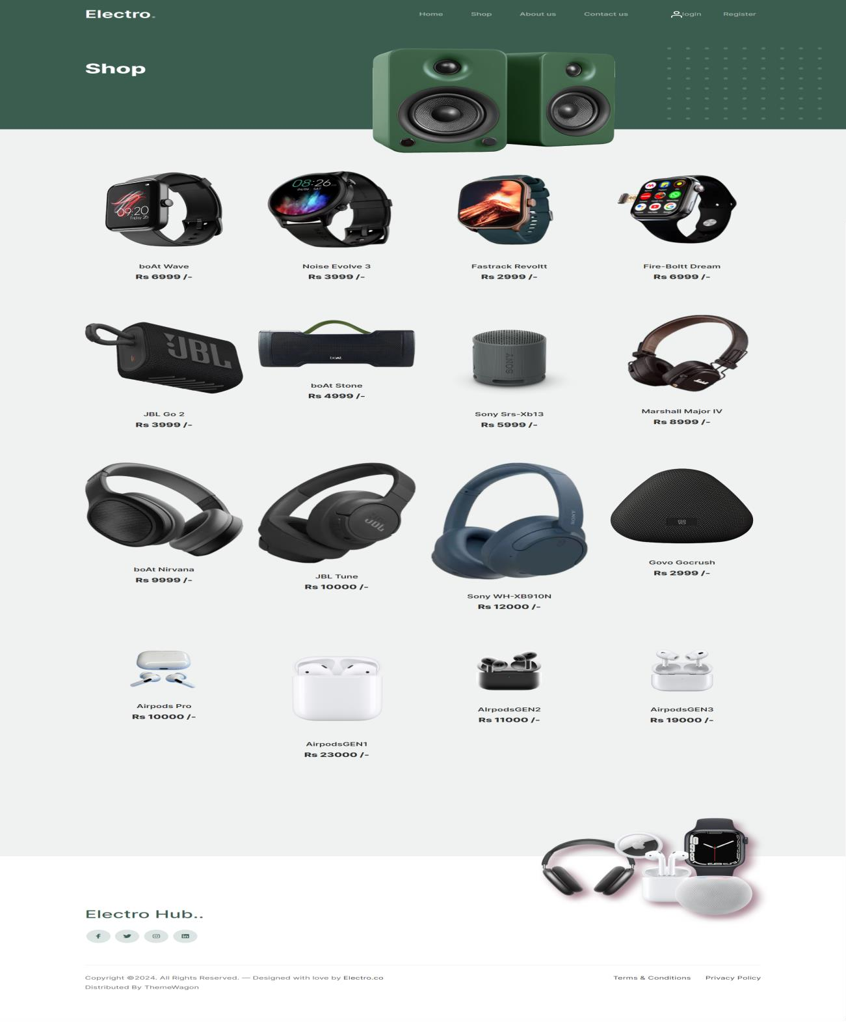

This is shop page.

* 1. **Add to Cart**

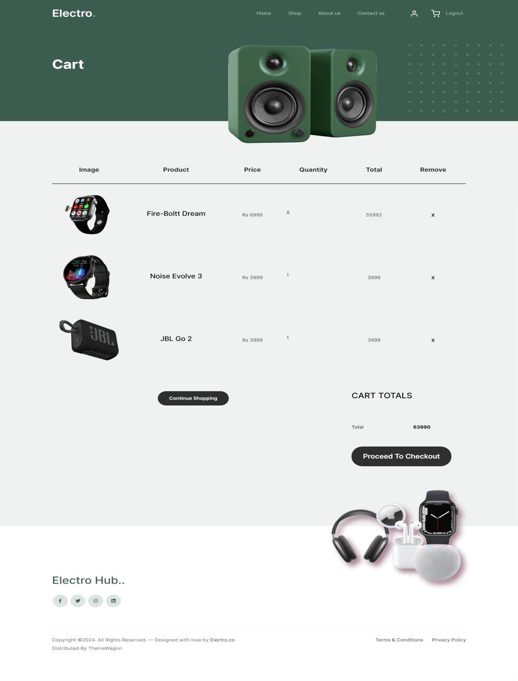

This is cart page.

* 1. **Checkout**

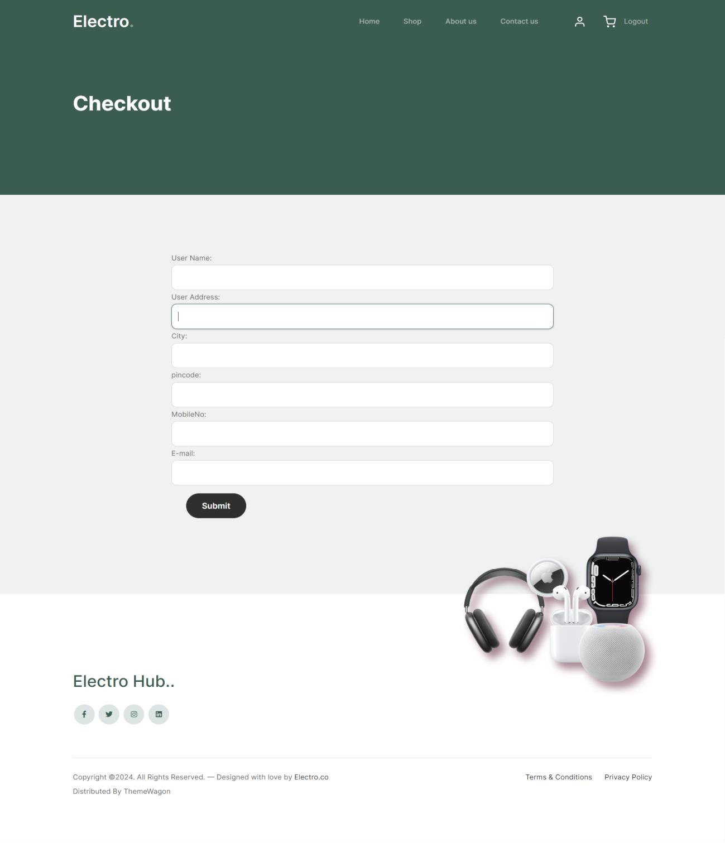

This is checkout page.

* 1. **Thankyou**

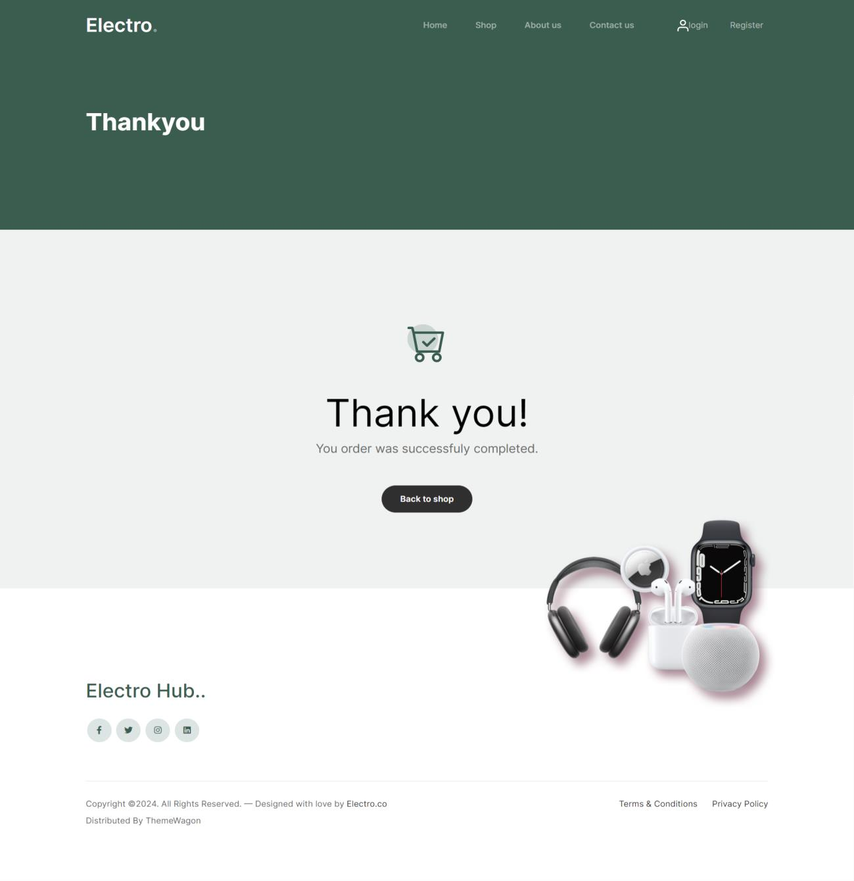

This is Thankyou page.

# TESTING

Site testing is a basic component of site quality confirmation and addresses a definitive survey of determination, plan, and coding. Testing addresses a fascinating irregularity for the Site. The testing stage includes testing of the framework utilizing different test information. Planning of test information assumes a crucial part in framework testing. Subsequent to setting up the test information, the framework under review is tried utilizing those test information. In the event that testing is led effectively, it uncovers the mistakes in the Site. Also, testing exhibits that Site capabilities seem, by all accounts, to be working as per particular and execution necessities seem to have been met. Likewise information gathered as testing is led gives a decent sign of Site dependability and some sign of Site quality all in all.

The improvement of the Site frameworks includes a progression of creation exercises where valuable open doors for infusion of human questionability are gigantic. Mistakes might start to happen at very commencement of the cycle where the goals might be wrongly or defectively determined as well as in later plan and advancement stages. In light of human failure to perform and speak with flawlessness, Site improvement is trailed by a quality confirmation movement.

**6.1 Test Cases**

In Website engineering, the most common definition of a test case is a set of conditions or variables under which a tester will determine if a requirement or use case upon an application is partially or fully satisfied. It may take many test cases to determine that a requirement is fully satisfied. In order to fully test that all the requirements of an application are met.

**Login Test**

|  |  |  |  |
| --- | --- | --- | --- |
| **Sr. No.** | **Test Case** | **Expected Results** | **Actual**  **Result** |
| 1. | Try to login with empty fields in the username and password text  boxes | An error message is displayed:  “Username is required Password is required” | Pass |
| 2. | Enter invalid username and  password | An error message is displayed:  “Invalid username or password” | Pass |
| 3. | Click on any feature on the website. | On clicking on any feature, check whether the user has logged in or not. | Pass |

***Table 6.2: Login Test Cases***

**Register Test**

|  |  |  |  |
| --- | --- | --- | --- |
| **Sr. No.** | **Test Case** | **Expected Results** | **Actual**  **Result** |
| 1. | Try to register with empty fields in the name, gender, contact,  text boxes | An error message is displayed: | Pass |
| 2. | Enter invalid  email, password | An error message is displayed: | Pass |

***Table 6.3: Register Test Cases***

7 Limitations & Future Extensions

# LIMITATIONS & FUTURE EXTENSIONS

**7.1 LIMITATIONS:**

* Require more accuracy.
* Provide less functionality.
* In this no OTP system is available.
* In this no notification, message and E-mail facility available.
* User can’t do online payment.
* User can’t track the order.
* User can’t return the order.

**7.2 FUTURE EXTENSIONS:**

In an advance technology we provide more and more satisfaction to users.

* In the future we added OTP system to Register.
* In future we gave a Notification, Message and E-mail facility.
* User can do payment online.
* User can do track the order.
* User can do return the order.

8 Conclusion and References

# CONCLUSION AND REFERENCES

**8.1 CONCLUSION**

It has been a great pleasure for us to work on this exciting and challenging project. This project proved good for us as it provided practical knowledge of not only programming in ASP.NET application and no some extent Windows Application My SQL Server, but also about all handling procedure related with “job searching”.

It also provides knowledge about the latest technology used in developing web enabled application and client server technology that will be great demand in future. This will provide better opportunities and guidance in future in developing projects independently.

Our project Electrohub is website useful to users who want to purchase electronics accessories. The user have to provide their details before purchase an accessories. In today’s people are so busy that he/she has no time for visit electronics shop and then do purchase, if user do that it is quite expensive and more time will consume.

**8.2 REFERENCES**

**Websites:**

* [www.banggood.in](http://www.banggood.in/)
* www.monoprice.com